DEMO REQUIREMENTS
Recommend Plate Collections Based on Restaurant Requirements
  - USER choice: “Dinnerware for an Italian Restaurant”

Option A – ABCO (Classic Bright White Porcelain)
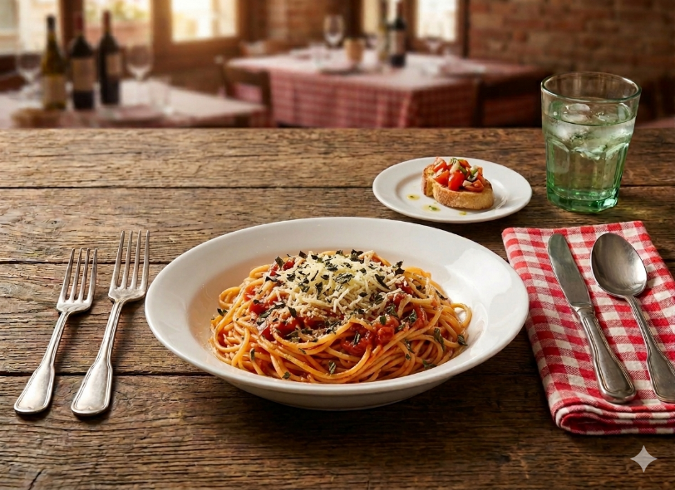
Item No’s: AC-16, AC-3
Link: https://yancochina.com/wp-content/uploads/2026/04/63AC_merge.pdf

Option B – GREEN BAND (Green Rim Pattern Stoneware)
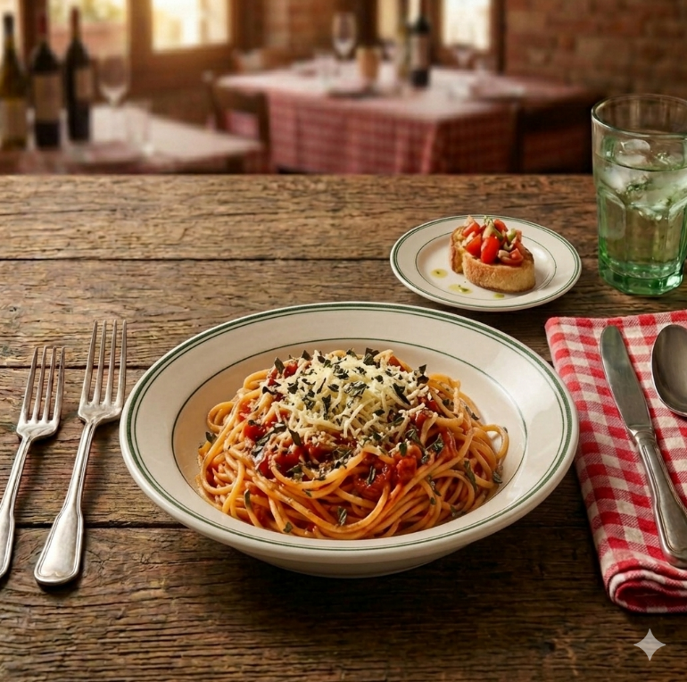
Item No’s: GB-16, GB-3
Link: https://yancochina.com/wp-content/uploads/2026/04/77GB_merge.pdf

  - USER choice: “Blue Plates for Greek Restaurant”

Option A – MARS (Blue Rim Patterned Chinaware)
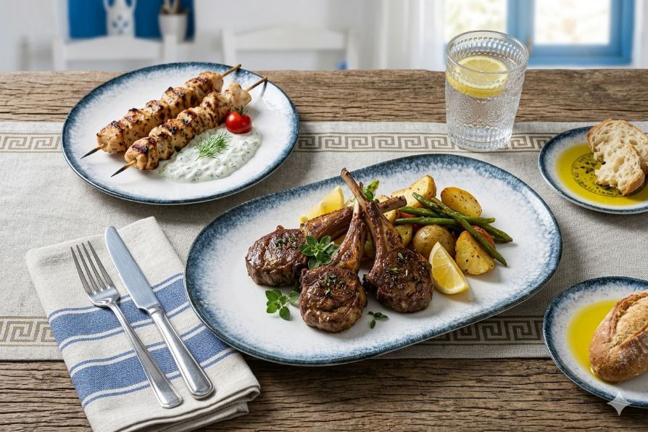
Item No’s: MR-706, MR-710, MR-214
Full Collection: https://yancochina.com/wp-content/uploads/2026/04/09MR_merge.pdf

Option B – SENTRY (Blue Design Melamine – for outdoor settings)
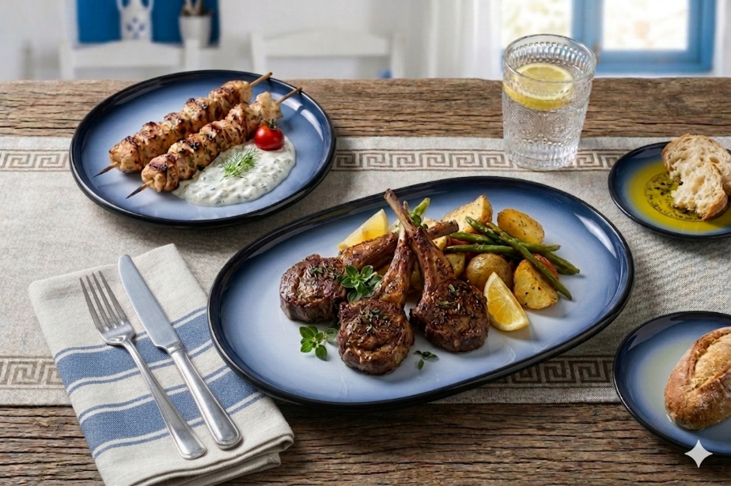
Item No’s: SN-107, SN-110, SN-214
Full Collection: https://yancochina.com/wp-content/uploads/2026/04/91SN_merge.pdf

  - USER choice: “Modern Appetizer Plate for Chicken Wings & Onion Rings ”

Option A – DIAMOND BLACK (Dark Bronze Matte Porcelain)
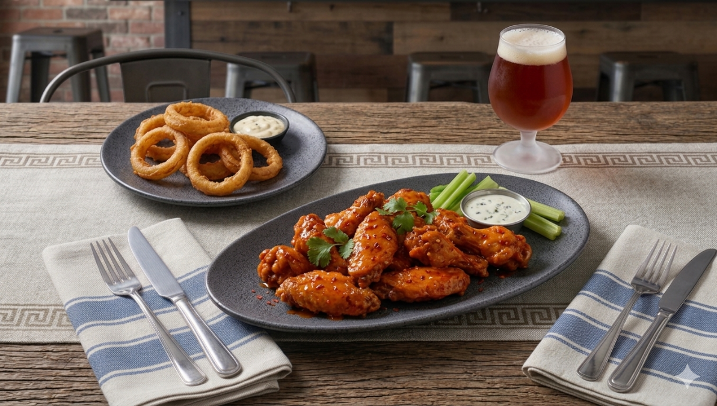
Item No’s: DB-109, DB-314
Full Collection: https://yancochina.com/wp-content/uploads/2026/04/15DB_merge.pdf

Option B – MODERNE (Matte Black Melamine)
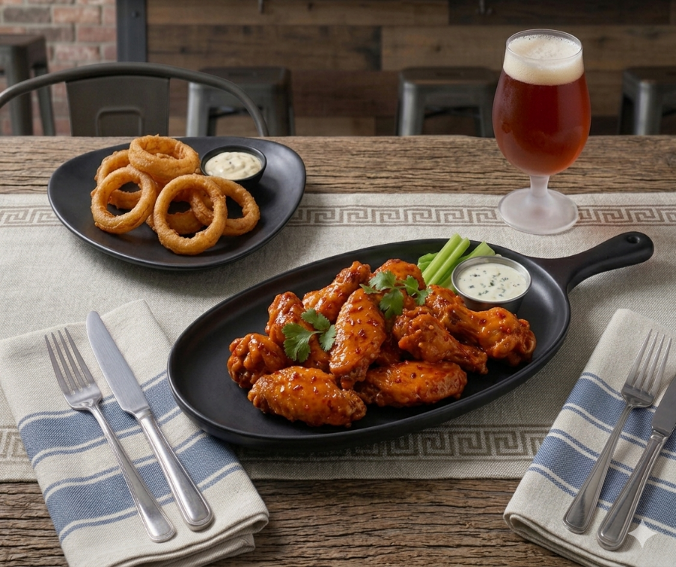
Item No’s: DB-109, DB-314
Full Collection: https://yancochina.com/wp-content/uploads/2026/04/120MO.pdf

